**Module-3: Docker – I Assignment – 1**

**● Pull ubuntu container.**

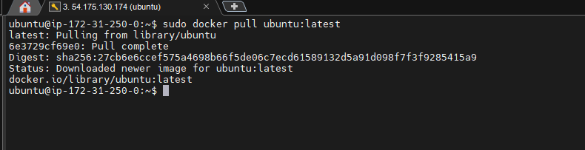

**● Run this container, and map port 80 on the local.**

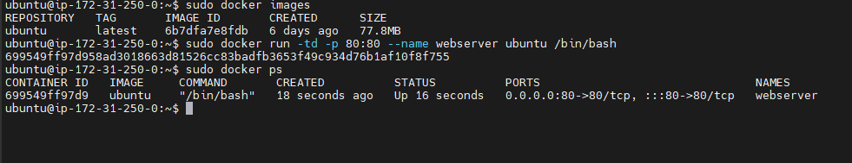

**● Install apache2 on this container.**

